


Department of Information Technology

Final Year SDD Report
Presented By: Muhammad Kamil
Roll Number: S23BINFT1M01144

Section: 7th – 3M
Super Visor: Mr. Abdul Karim Nawaz

The Islamia University of Bahawalpur, Bahawalpur

REVISION HISTORY
Version | Date | Author | Changes
1.0 | March 2026 | Muhammad Kamil | Initial SDD draft – architecture and data models
1.1 | April 2026 | Muhammad Kamil | Added UML diagrams, data dictionary, API interfaces
1.2 | May 2026 | Muhammad Kamil | Added test cases, constraints, risk analysis; finalized document

CHAPTER 1: INTRODUCTION

1.1 Purpose of This Document
This Software Design Description (SDD) provides a complete and detailed description of the design of the Symptom Checker and Hospital Navigation System. Its purpose is to translate the functional and non-functional requirements defined in the Software Requirements Specification (SRS) into a concrete design blueprint that can be used to guide actual software development.
This document describes the system architecture, component structure, database design, data flow, class relationships, interface definitions, and test specifications. It is intended for use by the developer (Muhammad Kamil) during implementation and by the supervisor (Mr. Abdul Karim Nawaz) during review and evaluation.

1.2 Scope
The Symptom Checker and Hospital Navigation System is a web-based healthcare application targeted at ordinary Pakistani citizens who need help assessing the urgency of their symptoms and locating suitable medical facilities nearby. The system does not provide formal medical diagnosis. It uses the Gemini API to perform AI-assisted urgency triage, classifying symptoms into one of three categories: emergency, semi-urgent, or routine.
Beyond symptom analysis, the system provides an interactive hospital map powered by the Google Maps API, online appointment booking with Twilio SMS reminders, insurance compatibility checking, and a personal health history dashboard. An admin panel allows authorized staff to manage hospital listings and user accounts.
The system is accessible from any modern web browser on desktop or mobile devices. No client-side installation is required.

1.3 Definitions, Abbreviations and Acronyms
Term | Description
SDD | Software Design Description
SRS | Software Requirements Specification
API | Application Programming Interface – enables communication between software systems
AI | Artificial Intelligence
JWT | JSON Web Token – used for stateless user authentication
MERN | MongoDB, Express.js, React.js, Node.js – the technology stack used in this project
DFD | Data Flow Diagram
ER | Entity Relationship
MongoDB | A NoSQL document-oriented database used to store application data
React.js | A JavaScript library for building user interfaces
Node.js | A JavaScript runtime for server-side code execution
Express.js | A web framework built on top of Node.js
Tailwind CSS | A utility-first CSS framework for UI styling
Redis | An in-memory caching layer to reduce database load
Twilio | A cloud communications platform for SMS reminders
Gemini API | Google's large language model API for symptom analysis
GUI | Graphical User Interface
CRUD | Create, Read, Update, Delete – basic database operations
HTTPS | Hypertext Transfer Protocol Secure – encrypted communication
OTP | One-Time Password
bcrypt | A password hashing library used for secure credential storage

1.4 Intended Audience
This document is intended for:
- The developer (Muhammad Kamil) as a guide during implementation
- The project supervisor (Mr. Abdul Karim Nawaz) for design review and grading
- The Department of Information Technology for academic evaluation
- Any future developer who maintains or extends this system

1.5 System Constraints
The following constraints govern the system and must be understood before development:
- The system requires an active internet connection at all times. No offline mode exists.
- The system does NOT provide formal or legal medical diagnosis. It only provides AI-assisted urgency triage. A clear disclaimer must be displayed on every results page.
- SMS reminders only support Pakistani mobile number formats (11-digit, starting with 03).
- The Google Maps API and Gemini API require valid API keys and active billing accounts on Google Cloud Platform.
- The Twilio SMS feature requires a funded Twilio account with a registered sender number.
- The system only supports web browsers. No native Android or iOS application exists.
- Admin accounts can only be created manually by a system administrator. Self-registration for admin roles is not allowed.
- The system assumes hospital data is maintained accurately by the admin. Stale data is the admin's responsibility.

1.6 Assumptions and Dependencies
Assumptions:
- Users will grant browser location permission when prompted. Without it, the hospital map cannot center on the user's position.
- Users have provided a valid Pakistani mobile number during registration for SMS delivery to work.
- The Gemini API will return a structured JSON response in the expected format with urgency classification and condition description fields.
- Hospital data stored in MongoDB is kept current by the system administrator.
External Dependencies:
- Google Maps JavaScript API – requires active billing on Google Cloud
- Gemini API – requires Google Cloud project credentials
- Twilio SMS API – requires active Twilio account and registered sender number
- MongoDB Atlas – cloud-hosted database service
- Node.js runtime environment on the hosting/deployment server

1.7 User Characteristics
Patient / General User: Ordinary Pakistani citizens aged approximately 18 to 60. Assumed to have basic smartphone literacy and the ability to use a web browser, fill in forms, and read English text. Not assumed to have any medical knowledge or technical skills.
System Administrator: A technically literate staff member responsible for managing hospital data and user accounts. Expected to work on a desktop browser and have basic data entry and management skills.

CHAPTER 2: ADOPTED DEVELOPMENT MODEL

2.1 Agile Development Model
The Agile development methodology was selected for this project because of the iterative and flexible nature required when building a healthcare web application. Healthcare applications frequently require revisions based on usability feedback, and the distinct features of this system – symptom analysis, hospital mapping, appointment booking, and admin management – are best developed and tested independently before integration.
Agile breaks the project into small, manageable development cycles called sprints, each lasting two to four weeks. At the end of each sprint, a working, testable piece of software is delivered and reviewed. This model allows the developer to respond to changing requirements without disrupting the overall project plan.

2.2 Sprint Plan
Sprint | Duration | Deliverable
Sprint 1 | Weeks 1–3 | User authentication system: registration, login, JWT-based sessions, password hashing with bcrypt, account management using Node.js, Express.js, and MongoDB.
Sprint 2 | Weeks 4–6 | Symptom input interface and Gemini API integration: urgency classification (emergency / semi-urgent / routine) and condition description returned to the user.
Sprint 3 | Weeks 7–9 | Hospital and clinic mapping feature: Google Maps API integration, browser geolocation, map rendering, hospital markers, distance and specialization filters.
Sprint 4 | Weeks 10–11 | Appointment booking system, insurance verification feature, and Twilio-based SMS reminders.
Sprint 5 | Weeks 12–14 | User dashboard for symptom history, admin panel, Redis caching for performance, final integration testing, and documentation completion.

2.3 Key Features of the Agile Model
- Iterative delivery: working software is produced at the end of every sprint.
- Customer collaboration: requirements are reviewed after each sprint cycle.
- Flexibility: requirement changes can be incorporated at any sprint boundary without breaking progress.
- Continuous testing: each sprint includes a dedicated testing phase before the next sprint begins.
- Reduced integration risk: each component is tested individually before being combined with others.

2.4 Agile Model Diagram – Description for Figure 2.1
Figure 2.1 shows the Agile sprint cycle. The diagram should be drawn as a circular loop with the following stages arranged around the loop in clockwise order:
- Plan – define sprint goals and select user stories
- Design – create or update design for the sprint's features
- Develop – write code for the planned features
- Test – unit test and integration test within the sprint
- Review – demonstrate working software to supervisor
- Retrospect – identify what went well and what to improve

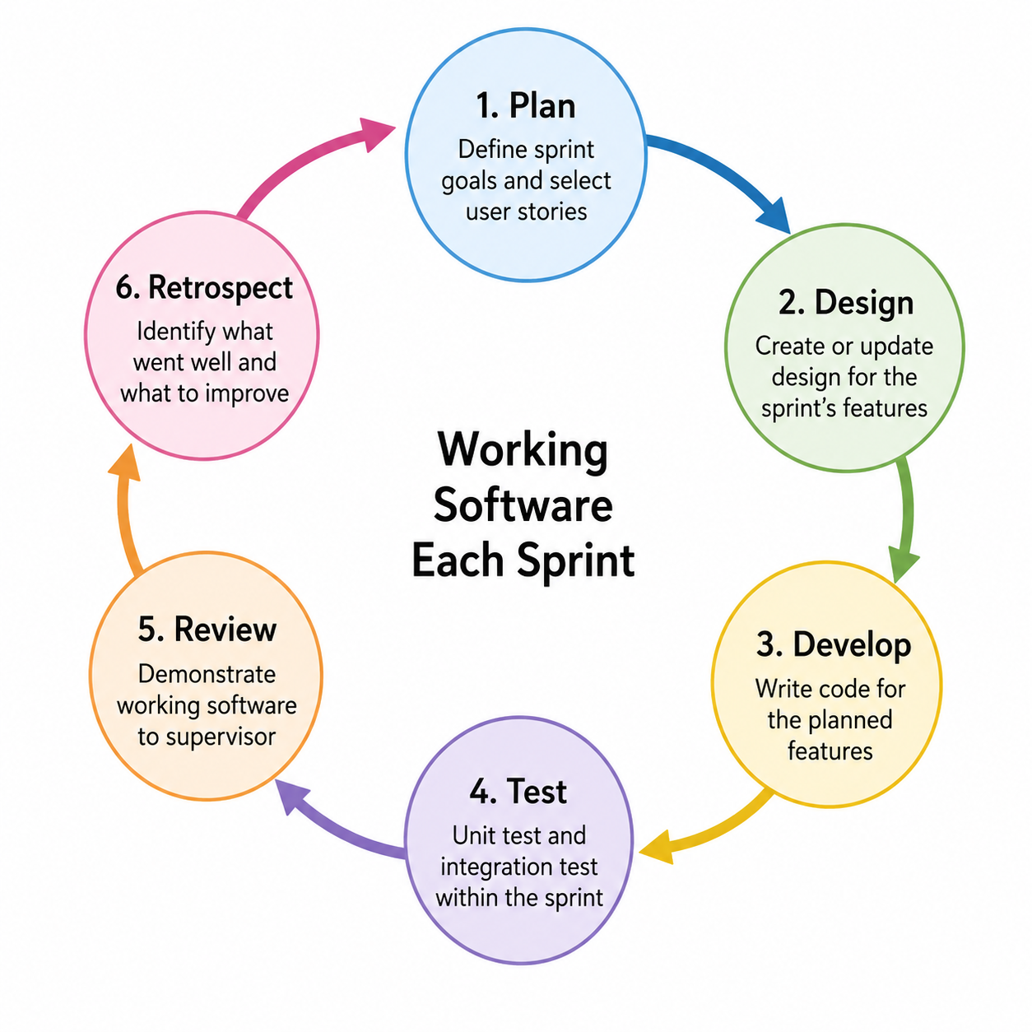

CHAPTER 3: SYSTEM ARCHITECTURE

3.1 Architectural Design Overview
The Symptom Checker and Hospital Navigation System follows a three-tier client-server architecture built on the MERN stack (MongoDB, Express.js, React.js, Node.js). The three tiers are:
- Presentation Tier (Frontend): A React.js single-page application (SPA) styled with Tailwind CSS. The frontend runs entirely in the user's browser and communicates with the backend exclusively through RESTful API calls over HTTPS.
- Application Tier (Backend): A Node.js runtime running an Express.js web server. This tier handles all business logic, processes API requests, validates JWT authentication tokens, communicates with third-party services (Gemini API, Google Maps API, Twilio), and reads/writes data to the database.
- Data Tier (Database): A MongoDB database hosted on MongoDB Atlas. Redis is used as an in-memory caching layer in front of MongoDB for frequently accessed data such as hospital listings, reducing database load and improving response times.

3.2 System Modules
The system is divided into three primary functional modules:
Patient Module: Users can register and log in, enter symptoms and receive AI urgency analysis, browse hospitals on an interactive map with filters, check insurance compatibility, book appointments, and view their personal health dashboard.
Admin Module: Administrators can log in to a separate admin panel, perform CRUD operations on hospital and clinic records, manage registered user accounts, view all appointments across the platform, and access usage analytics reports.
Hospital Data Module: Manages stored information about healthcare facilities including geographic coordinates, specializations, operating hours, accepted insurance plans, and availability status. This data is served to the Google Maps API for map rendering.

3.3 Security Design
Authentication is implemented using JWT (JSON Web Tokens). After a successful login, the backend generates a signed JWT containing the user's ID and role. This token is stored on the client side and included in the Authorization header of every request to a protected API route. The backend middleware verifies the token's signature and expiry on each request before processing it.
User passwords are never stored in plain text. They are hashed using bcrypt with a salt factor of 10 before being written to the database. All communication between the frontend and backend occurs over HTTPS to prevent interception. The admin panel is accessible only to accounts with the admin role assigned manually – users cannot self-promote to admin.

3.4 Tools and Technologies
Technology | Category | Purpose in This System
React.js | Frontend | Builds the single-page application UI as reusable components
Tailwind CSS | Frontend | Utility-first CSS framework for rapid, consistent UI styling
Node.js | Backend | Server-side JavaScript runtime; handles API requests and business logic
Express.js | Backend | Web framework for defining API routes, middleware, and request handling
MongoDB | Database | NoSQL document store for users, hospitals, appointments, symptom records
Redis | Caching | In-memory cache for hospital listings; reduces MongoDB query load
Google Maps API | External API | Renders interactive hospital map; handles geolocation and distance calculation
Gemini API | External API | AI-based symptom analysis; returns urgency level and condition description
Twilio | External API | Sends SMS appointment reminders to user's mobile number
JWT | Security | Stateless authentication tokens issued at login, verified on every request
bcrypt | Security | Password hashing before storage; protects credentials in case of data breach
Git / GitHub | Dev Tools | Version control and project repository management

3.5 Data Flow Diagram

3.5.1 Context Level DFD (Level 0)
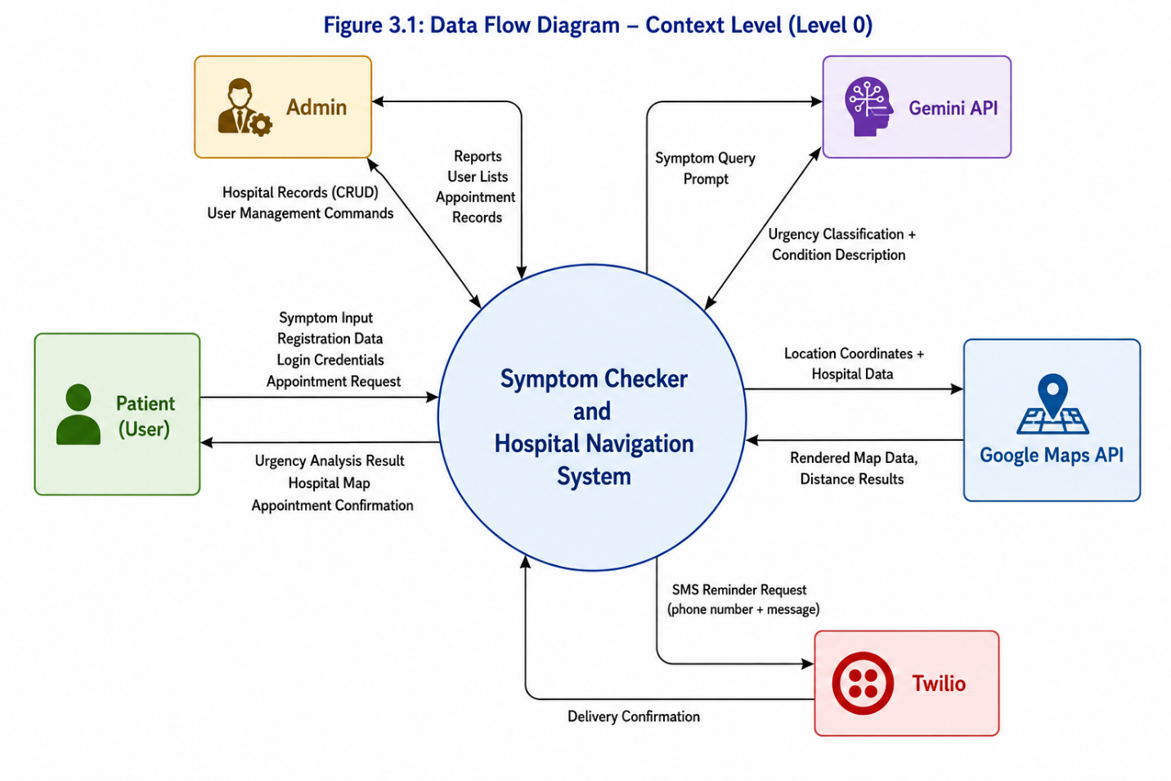

3.5.2 Level 1 DFD – Major Processes
The Level 1 DFD breaks the central system bubble into five numbered processes. Each process connects to relevant data stores and external entities. The data stores are drawn as open-ended rectangles labeled D1 through D5.
Process | Name | Data Stores Used | External Entities
1.0 | User Authentication | D1: Users Collection | Patient
2.0 | Symptom Analysis | D1: Users, D2: SymptomRecords | Patient, Gemini API
3.0 | Hospital Search | D3: Hospitals Collection (via Redis) | Patient, Google Maps API
4.0 | Appointment Management | D1: Users, D4: Appointments, D3: Hospitals | Patient, Twilio
5.0 | Admin Management | D1, D3, D4 (all collections) | Admin

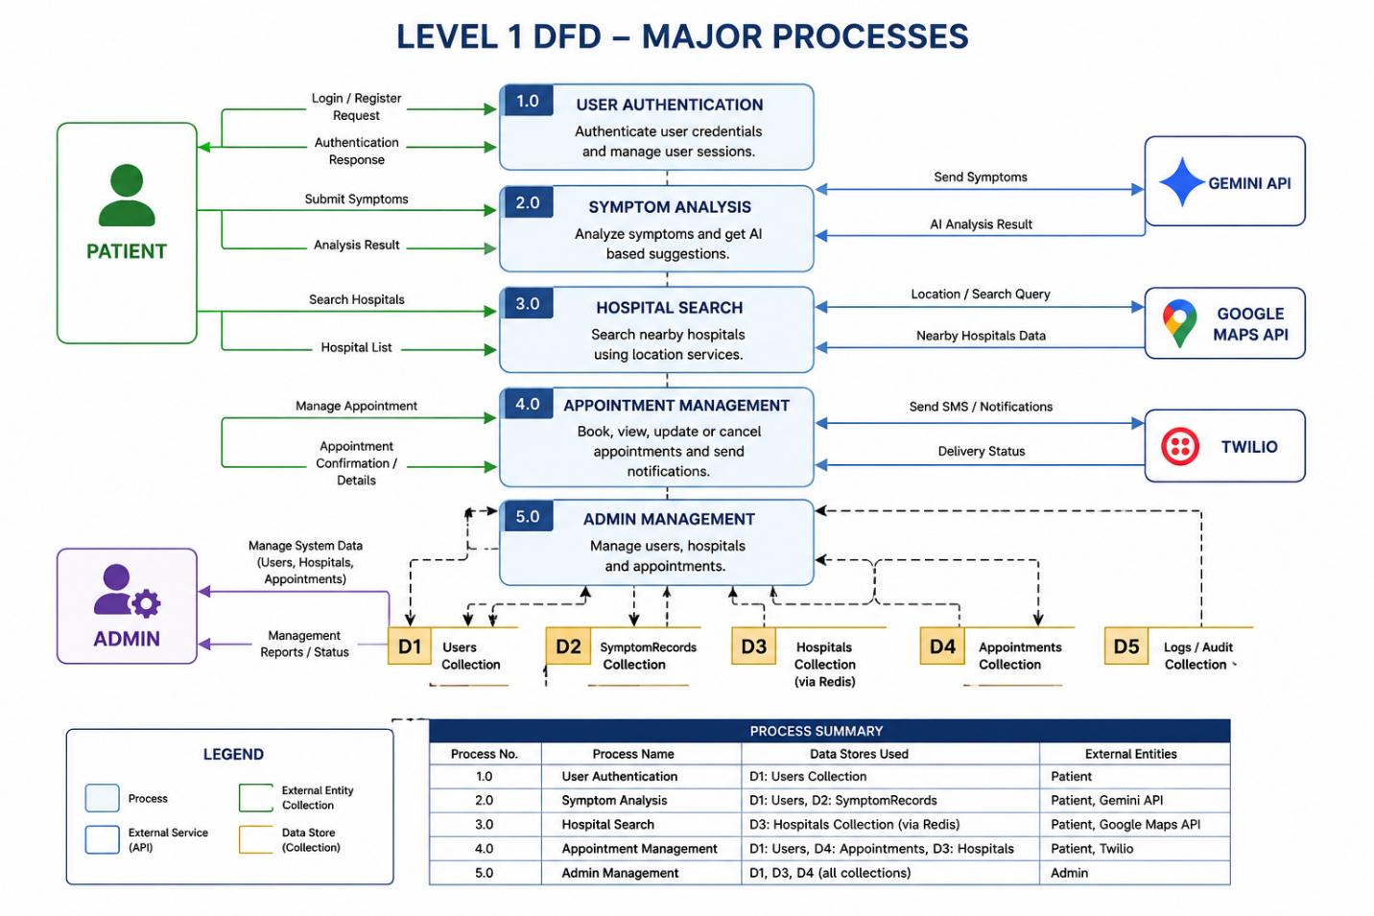

3.6 Entity Relationship Diagram

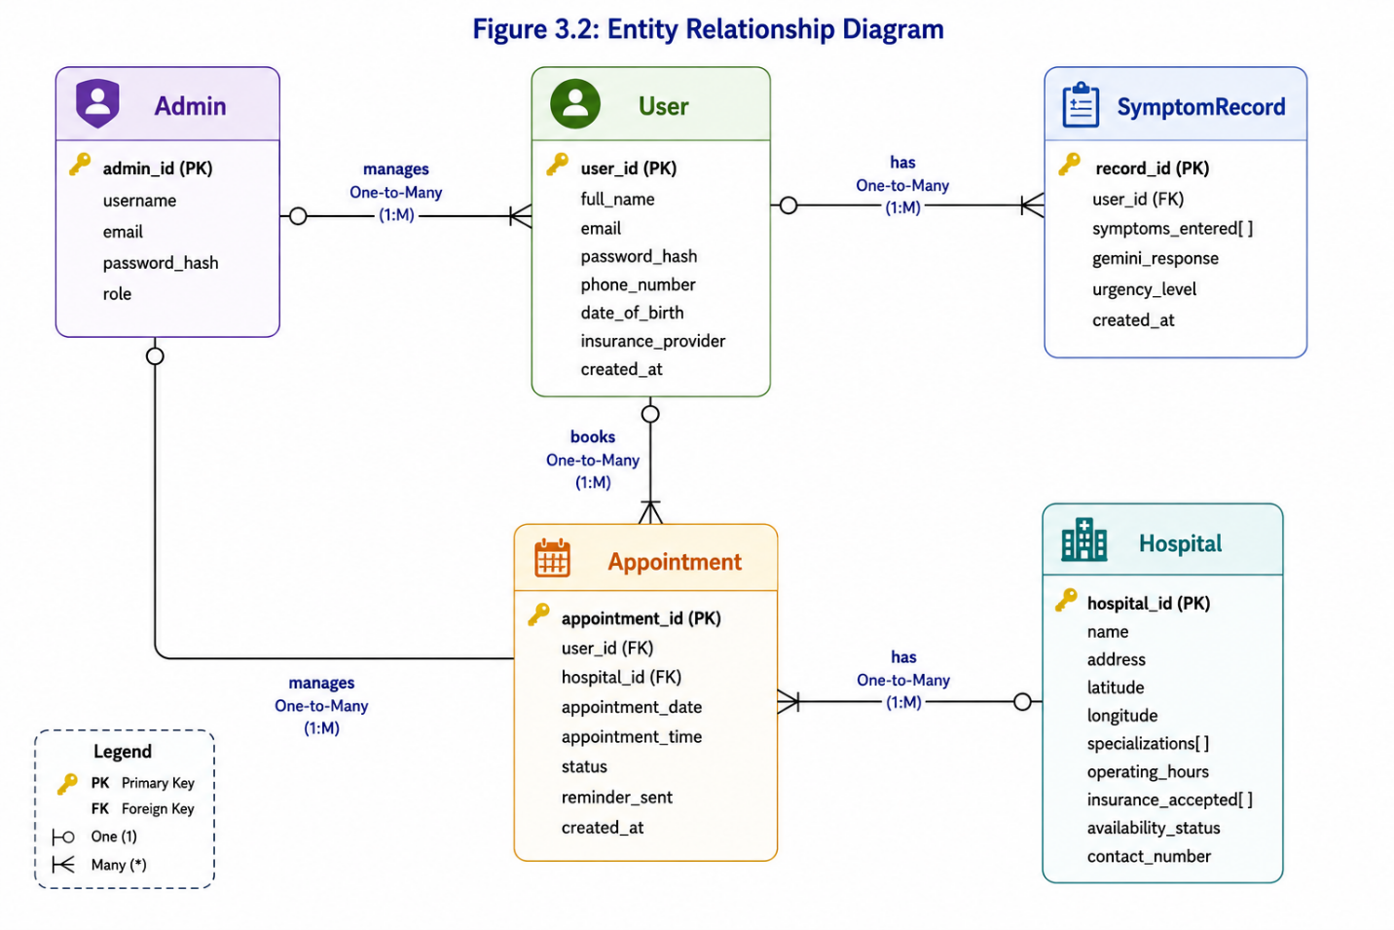

3.7 Use Case Diagram

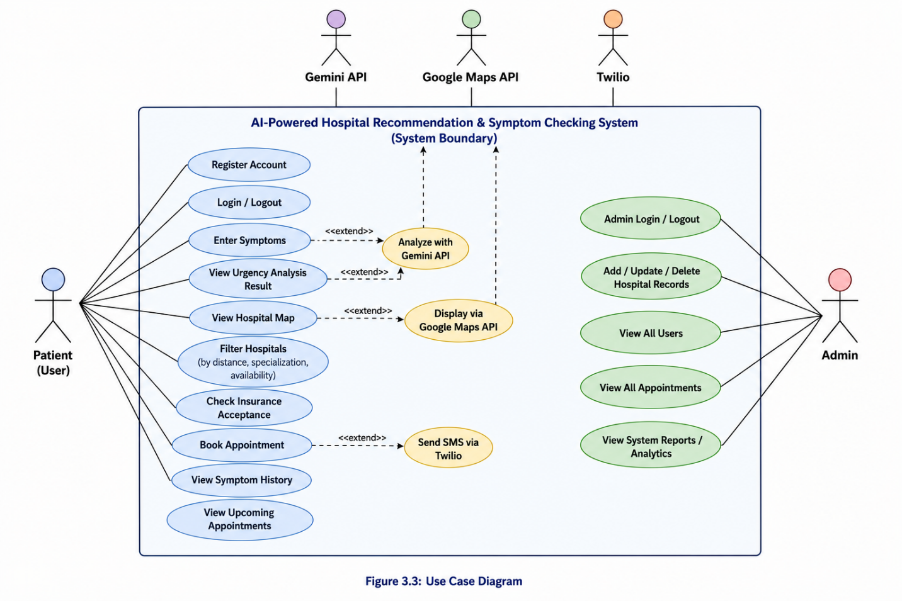

3.8 Activity Diagram for Admin
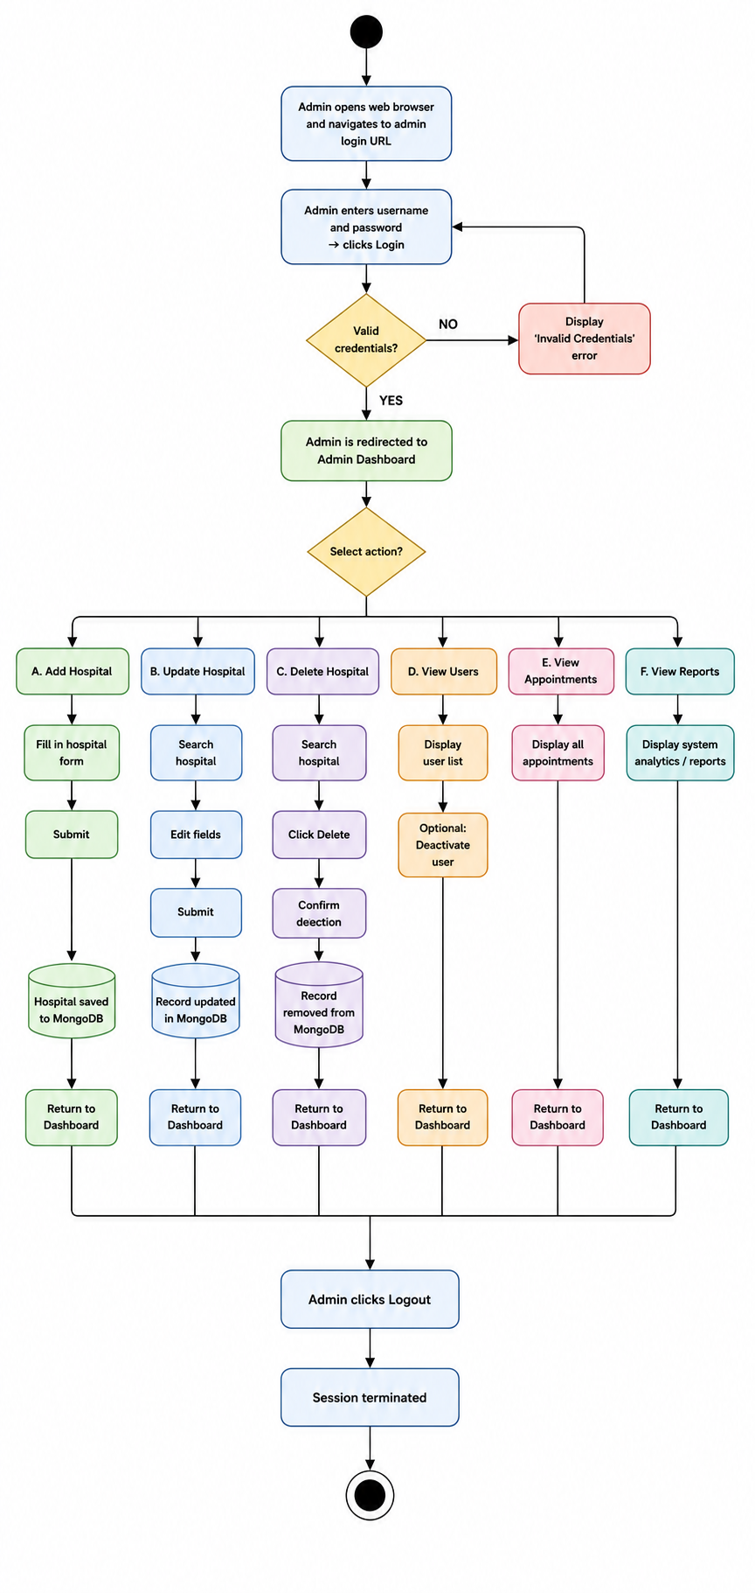

3.9 Activity Diagram for Patient

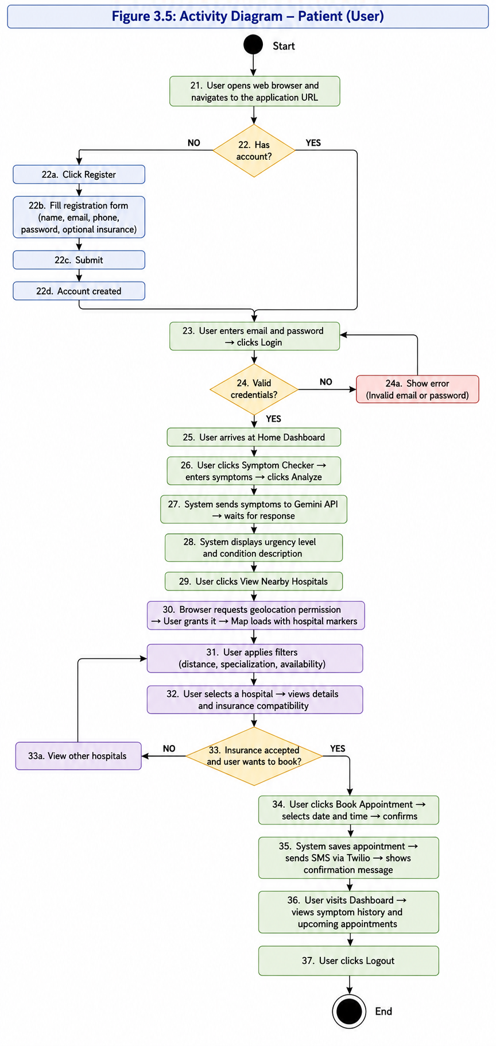

3.10 Sequence Diagram – Symptom Checking Flow

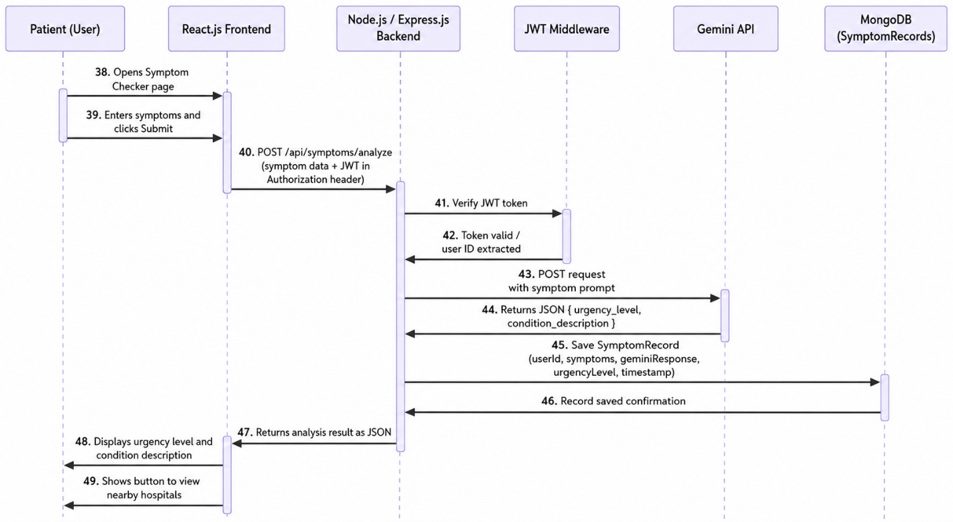

3.11 Class Diagram Design

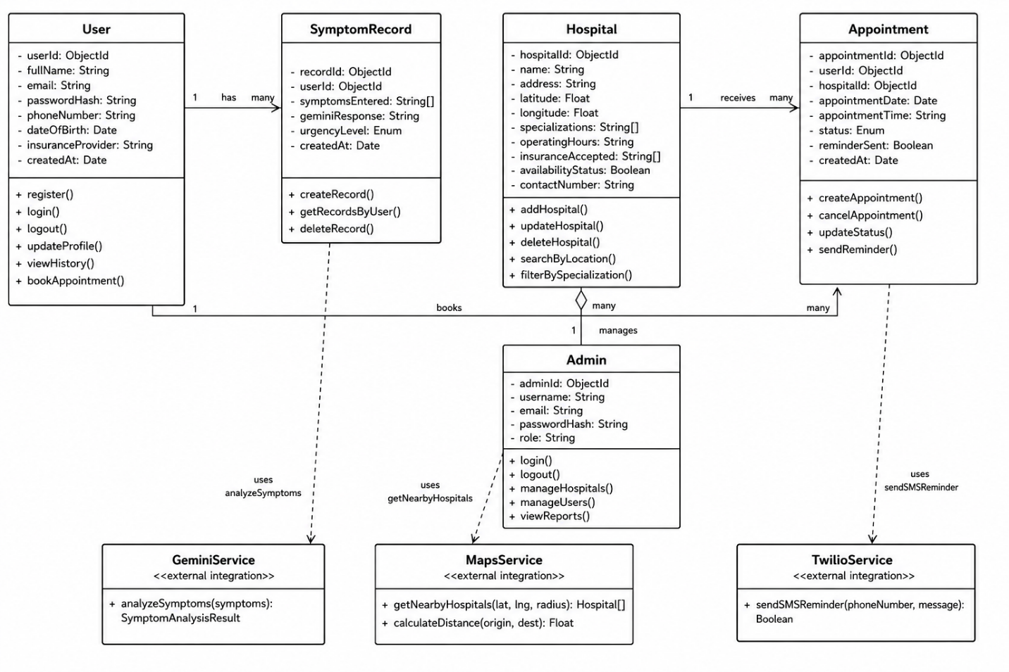

Class | Attributes | Methods
User | - userId: ObjectId - fullName: String - email: String - passwordHash: String - phoneNumber: String - dateOfBirth: Date - insuranceProvider: String - createdAt: Date | + register() + login() + logout() + updateProfile() + viewHistory() + bookAppointment()
SymptomRecord | - recordId: ObjectId - userId: ObjectId - symptomsEntered: String[] - geminiResponse: String - urgencyLevel: Enum - createdAt: Date | + createRecord() + getRecordsByUser() + deleteRecord()
Hospital | - hospitalId: ObjectId - name: String - address: String - latitude: Float - longitude: Float - specializations: String[] - operatingHours: String - insuranceAccepted: String[] - availabilityStatus: Boolean - contactNumber: String | + addHospital() + updateHospital() + deleteHospital() + searchByLocation() + filterBySpecialization()
Appointment | - appointmentId: ObjectId - userId: ObjectId - hospitalId: ObjectId - appointmentDate: Date - appointmentTime: String - status: Enum - reminderSent: Boolean - createdAt: Date | + createAppointment() + cancelAppointment() + updateStatus() + sendReminder()
Admin | - adminId: ObjectId - username: String - email: String - passwordHash: String - role: String | + login() + logout() + manageHospitals() + manageUsers() + viewReports()
GeminiService | (external integration) | + analyzeSymptoms(symptoms): SymptomAnalysisResult
MapsService | (external integration) | + getNearbyHospitals(lat, lng, radius): Hospital[] + calculateDistance(origin, dest): Float
TwilioService | (external integration) | + sendSMSReminder(phoneNumber, message): Boolean

3.12 Data Dictionary

3.12.1 Users Collection
Field | Description | Data Type | Constraints
user_id | Unique identifier for each user | ObjectId | PK, Auto-generated
full_name | Full name of the registered patient | String | Max 100 chars, letters and spaces only
email | Email address used for login | String | Max 256 chars, unique, valid email format
password_hash | bcrypt-hashed user password | String | 60 chars, system-generated
phone_number | Mobile number for SMS reminders | String | 11 digits, Pakistani format (03XX)
date_of_birth | Patient's date of birth | Date | ISO 8601 format
insurance_provider | Name of health insurance company | String | Max 100 chars, optional field
created_at | Account creation timestamp | Date | Auto-generated at registration

3.12.2 SymptomRecord Collection
Field | Description | Data Type | Constraints
record_id | Unique identifier for each symptom session | ObjectId | PK, Auto-generated
user_id | Reference to the user who submitted symptoms | ObjectId | FK → Users, required
symptoms_entered | Array of symptoms entered by the user | Array of Strings | Max 20 items, each max 100 chars
gemini_response | Full text response from Gemini API | String | Max 2000 chars
urgency_level | Urgency classification result | Enum | Values: emergency, semi-urgent, routine
created_at | Timestamp of the symptom check | Date | Auto-generated

3.12.3 Hospital Collection
Field | Description | Data Type | Constraints
hospital_id | Unique identifier for each facility | ObjectId | PK, Auto-generated
name | Official name of the healthcare facility | String | Max 200 chars
address | Physical street address | String | Max 300 chars
latitude | Geographic latitude coordinate | Float | Valid geographic range
longitude | Geographic longitude coordinate | Float | Valid geographic range
specializations | List of medical specialties offered | Array of Strings | e.g., Cardiology, Orthopedics
operating_hours | Operating hours schedule | String | Formatted schedule string
insurance_accepted | List of insurance providers accepted | Array of Strings | e.g., Jubilee, EFU, Sehat Sahulat
availability_status | Whether facility is currently active | Boolean | True / False
contact_number | Main contact number | String | Max 15 chars

3.12.4 Appointment Collection
Field | Description | Data Type | Constraints
appointment_id | Unique identifier for each booking | ObjectId | PK, Auto-generated
user_id | Reference to the patient who booked | ObjectId | FK → Users, required
hospital_id | Reference to the booked hospital | ObjectId | FK → Hospitals, required
appointment_date | Scheduled appointment date | Date | Must be a future date
appointment_time | Time slot of the appointment | String | Format: HH:MM (24-hour)
status | Current booking status | Enum | Values: pending, confirmed, cancelled
reminder_sent | Whether SMS reminder has been dispatched | Boolean | Default: False
created_at | Timestamp of booking creation | Date | Auto-generated

3.12.5 Admin Collection
Field | Description | Data Type | Constraints
admin_id | Unique identifier for admin account | ObjectId | PK, Auto-generated
username | Admin display name for login | String | Max 50 chars, unique
email | Admin email address | String | Max 256 chars, unique
password_hash | bcrypt-hashed admin password | String | 60 chars, system-generated
role | Admin permission level | String | Default value: superadmin

CHAPTER 4: EXTERNAL INTERFACE REQUIREMENTS

4.1 Gemini API Interface
The backend sends an HTTPS POST request to the Gemini API endpoint with a structured prompt built from the user's entered symptoms. The prompt instructs Gemini to classify the urgency and describe likely conditions.
Property | Detail
Request Method | POST (HTTPS)
Endpoint | https://generativelanguage.googleapis.com/v1beta/models/gemini-pro:generateContent
Authentication | API Key passed as query parameter or in header (Google Cloud credentials)
Request Body | JSON containing a 'contents' array with a 'parts' array containing the symptom prompt text
Expected Response Fields | urgency_level (string: 'emergency' | 'semi-urgent' | 'routine'), condition_description (string, plain language)
Timeout | 5 seconds maximum wait; show error message to user if exceeded
Error Handling | If Gemini returns an error or unexpected format, display 'Analysis temporarily unavailable' and prompt the user to try again

4.2 Google Maps API Interface
Property | Detail
API Used | Google Maps JavaScript API
Location Source | Browser Geolocation API (navigator.geolocation.getCurrentPosition)
Map Initialization | The frontend receives lat/lng from the browser and passes them to Maps API to center the map
Hospital Markers | Hospital coordinates from MongoDB are sent to the frontend and rendered as clickable markers
Distance Calculation | Google Maps Distance Matrix API is used to calculate distances between user location and hospitals
Filters Applied | Filtering by specialization and availability is done on the MongoDB query before rendering markers
API Key Management | Key stored in backend environment variables; never exposed in frontend source code

4.3 Twilio SMS Interface
Property | Detail
API Used | Twilio REST API – Messages endpoint
Trigger | Called asynchronously after a successful appointment booking to avoid blocking the booking response
Recipient | User's phone number stored in the Users collection
Message Content | 'Your appointment at [Hospital Name] is confirmed for [Date] at [Time]. – Symptom Checker App'
Error Handling | If SMS fails, the appointment is still saved. A visual on-screen confirmation is always shown as backup. The failure is logged server-side.
Credentials | Twilio Account SID and Auth Token stored in backend environment variables (.env file)

4.4 User Interface Requirements
The following UI requirements guide the design of each major screen:
Screen | Key UI Requirements
Home Page / Landing Page | Navigation bar with Login and Register buttons; brief description of the system; call-to-action button for symptom checker; clean and readable layout on both desktop and mobile
Registration Page | Form fields: Full Name, Email, Password (min 8 chars), Mobile Number (Pakistani format), Insurance Provider (optional); Submit button; link to Login page; client-side and server-side validation with clear error messages
Login Page | Email and password fields; Login button; error message for invalid credentials that does not reveal which field is wrong; link to Register page
Symptom Checker | Text input field or tag-based entry for symptoms; Analyze button; loading spinner while Gemini API processes; result card showing urgency level (color-coded: red=emergency, amber=semi-urgent, green=routine) and condition description; prominent medical disclaimer
Hospital Map | Full-width Google Map centered on user's location; hospital markers with info popups; filter sidebar for distance, specialization, and availability; hospital detail card showing name, address, specializations, operating hours, insurance list, and Book Appointment button
Appointment Booking | Date picker; time slot selector; Confirm Booking button; success confirmation message; note that SMS reminder will be sent
User Dashboard | Summary cards for total symptoms checked, upcoming appointments, last urgency result; list of past symptom records with dates; list of upcoming appointments with cancel option
Admin Dashboard | Summary statistics at top; data tables for hospitals, users, and appointments; add/edit/delete controls; search and filter capabilities

CHAPTER 5: RISK ANALYSIS
The following table identifies the main risks to the project, their likelihood and impact, and the mitigation strategies applied.
Risk | Likelihood | Impact | Mitigation Strategy
Gemini API returns incorrect urgency classification | Medium | High | Display a clear disclaimer on all results pages stating results are not medical advice. Instruct users to consult a doctor for confirmation.
Google Maps API billing limit exceeded during heavy use | Medium | High | Implement Redis caching for hospital listings to reduce the number of API calls. Monitor usage via Google Cloud Console.
User enters false or misleading symptoms | High | Medium | The system cannot verify symptom input. A disclaimer is shown. The urgency triage is informational only and does not replace professional diagnosis.
Twilio SMS delivery failure | Low | Medium | SMS confirmation is asynchronous and non-blocking. A visual on-screen booking confirmation always appears regardless of SMS status. Failure is logged.
MongoDB Atlas service outage | Low | High | The application displays a graceful maintenance message rather than crashing. Critical booking confirmations should be saved to a local fallback queue.
JWT token stolen through XSS attack | Low | High | Tokens are short-lived (24-hour expiry). Content Security Policy headers are set. All user input is sanitized before rendering to prevent script injection.
User denies browser location access | Medium | Medium | The hospital map falls back to showing hospitals sorted by a default city (Bahawalpur). User can manually enter their location.
Gemini API rate limit reached | Low | Medium | Implement server-side request queuing and show a loading message to the user with automatic retry after a short delay.

CHAPTER 6: TEST SPECIFICATION AND RESULTS

6.1 Testing Approach
Testing follows an incremental approach aligned with the Agile sprints. Each sprint includes unit tests for individual components and integration tests for the connected features before the next sprint begins. The test cases below represent end-to-end functional tests conducted on the completed system.

Test Case 1: View Home Page
Field | Details
Test Case ID | TC-01
Test Case Title | View Home Page
Preconditions | Device with active internet connection and modern web browser (Chrome, Firefox, Edge, or Safari)
Test Steps | 1. Open web browser. 2. Enter the application URL in the address bar. 3. Wait for the page to load.
Expected Result | Home page loads successfully, displaying the navigation bar, symptom checker entry point, system description, and Login / Register buttons.
Tested By | Muhammad Kamil
Result | PASS

Test Case 2: User Registration
Field | Details
Test Case ID | TC-02
Test Case Title | User Registration
Preconditions | User is on the home page and does not already have an account with the entered email.
Test Steps | 1. Click Register. 2. Enter full name. 3. Enter valid email. 4. Enter password (min 8 characters). 5. Enter Pakistani mobile number. 6. Optionally enter insurance provider. 7. Click Submit.
Expected Result | Account created successfully. User is redirected to the dashboard with a welcome message.
Tested By | Muhammad Kamil
Result | PASS

Test Case 3: User Login
Field | Details
Test Case ID | TC-03
Test Case Title | User Login
Preconditions | User has a registered account.
Test Steps | 1. Navigate to Login page. 2. Enter registered email. 3. Enter password. 4. Click Login.
Expected Result | User is authenticated and redirected to personal dashboard. Invalid credentials display an error that does not reveal which field is wrong.
Tested By | Muhammad Kamil
Result | PASS

Test Case 4: Symptom Entry and AI Analysis
Field | Details
Test Case ID | TC-04
Test Case Title | Symptom Entry and AI Analysis
Preconditions | User is logged in. Gemini API is accessible.
Test Steps | 1. Navigate to Symptom Checker. 2. Enter symptoms (e.g., fever, headache, body aches). 3. Click Analyze Symptoms.
Expected Result | System returns urgency level (emergency / semi-urgent / routine) and plain-language condition description. Result is stored in user's symptom history.
Tested By | Muhammad Kamil
Result | PASS

Test Case 5: Hospital Search and Map Filters
Field | Details
Test Case ID | TC-05
Test Case Title | Hospital Search and Map Filters
Preconditions | User is logged in. Browser location access is allowed. Google Maps API is connected.
Test Steps | 1. Navigate to Hospital Finder. 2. Allow location access when prompted. 3. View hospitals on map. 4. Apply specialization filter (e.g., Cardiology). 5. Apply distance filter (e.g., within 5 km).
Expected Result | Map displays only hospitals matching the selected filters. Markers are visible. Clicking a marker shows hospital name, address, contact, and specializations.
Tested By | Muhammad Kamil
Result | PASS

Test Case 6: Appointment Booking
Field | Details
Test Case ID | TC-06
Test Case Title | Appointment Booking
Preconditions | User is logged in and has selected a hospital from the map.
Test Steps | 1. Click Book Appointment on selected hospital. 2. Select a date and time slot. 3. Click Confirm Booking.
Expected Result | Appointment saved to database. Confirmation message appears on screen. SMS is sent to registered phone via Twilio. Appointment appears in user's dashboard.
Tested By | Muhammad Kamil
Result | PASS

Test Case 7: Insurance Acceptance Check
Field | Details
Test Case ID | TC-07
Test Case Title | Insurance Acceptance Check
Preconditions | User is logged in and has entered their insurance provider during registration or profile update.
Test Steps | 1. Select a hospital from the map. 2. View the hospital detail card. 3. Observe the insurance compatibility indicator.
Expected Result | If user's insurance provider matches hospital's list: green 'Insurance Accepted' label displayed. Otherwise: 'Not Accepted' label shown.
Tested By | Muhammad Kamil
Result | PASS

Test Case 8: Admin Login and Hospital Management
Field | Details
Test Case ID | TC-08
Test Case Title | Admin Login and Hospital Management
Preconditions | Admin account must be created manually in the database with role: superadmin.
Test Steps | 1. Navigate to /admin/login. 2. Enter admin credentials. 3. Click Login. 4. Click Add Hospital. 5. Fill in all hospital fields. 6. Click Submit.
Expected Result | Admin is authenticated and lands on admin dashboard. New hospital record is saved and appears in the hospital list. Hospital is also visible on the user-facing map.
Tested By | Muhammad Kamil
Result | PASS

CHAPTER 7: GRAPHICAL USER INTERFACE DESIGN
This chapter describes the design of each major screen in the application. Since the project has not yet been built, these are design specifications that must be implemented. All screens must be responsive and function correctly on both desktop (minimum 1024px wide) and mobile (minimum 375px wide) viewports. The design uses Tailwind CSS utility classes.

7.1 Home Page / Landing Page
Layout: Full-width single-page design with a hero section at the top.
Components: Navigation bar at the top containing the app logo on the left and Login / Register buttons on the right. Below the navigation: a full-width hero banner with the heading 'Know Your Symptoms. Find the Right Care.' in large bold text, a subheading explaining the system in one sentence, and a prominent blue call-to-action button labeled 'Check Your Symptoms'. Below the hero: three feature cards in a horizontal row describing Symptom Analysis, Hospital Finder, and Appointment Booking. Footer with contact information.
Colors: Primary blue (#1F4E79 or Tailwind's blue-800) for buttons and headers. White background. Light gray (#F5F5F5) for feature card backgrounds.

7.2 Registration and Login Pages
Registration: Centered card layout on a light gray background. Fields: Full Name, Email, Password (with show/hide toggle), Confirm Password, Phone Number, and optional Insurance Provider. Submit button in primary blue. Link at bottom: 'Already have an account? Login here.'
Login: Centered card. Fields: Email and Password. Login button. Link: 'Don't have an account? Register here.' Error messages appear in red below the relevant field.

7.3 Symptom Checker Screen
Layout: Two-column layout on desktop (input on left, result on right). Single column on mobile.
Input area: A text area with placeholder 'Type your symptoms here, e.g., fever, chest pain, dizziness' and an 'Analyze Symptoms' button. A tag-based display optionally shows entered symptoms as removable chips.
Result area: After analysis, a result card appears. The urgency level is displayed in a large colored badge: red for Emergency, amber/yellow for Semi-Urgent, green for Routine. Below the badge, the condition description text from Gemini is shown. A disclaimer in small italic text reads: 'This result is not a medical diagnosis. Please consult a qualified doctor.'

7.4 Hospital Map Screen
Layout: Full-width Google Map taking 65% of the screen height. A collapsible filter sidebar on the left. A hospital detail panel on the right that appears when a marker is clicked.
Filter sidebar options: Distance slider (1 km to 50 km), Specialization dropdown (multi-select), and Availability toggle (Show only available facilities).
Hospital detail panel: Shows hospital name, address, phone, operating hours, list of specializations, list of accepted insurance plans, and insurance compatibility status (green/red based on user's saved insurance). A blue 'Book Appointment' button at the bottom.

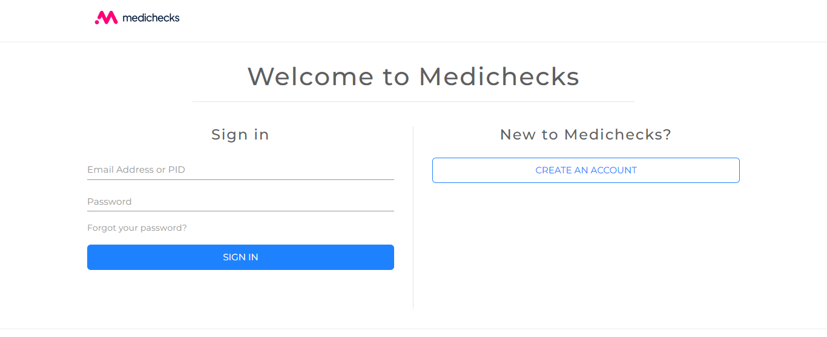 | 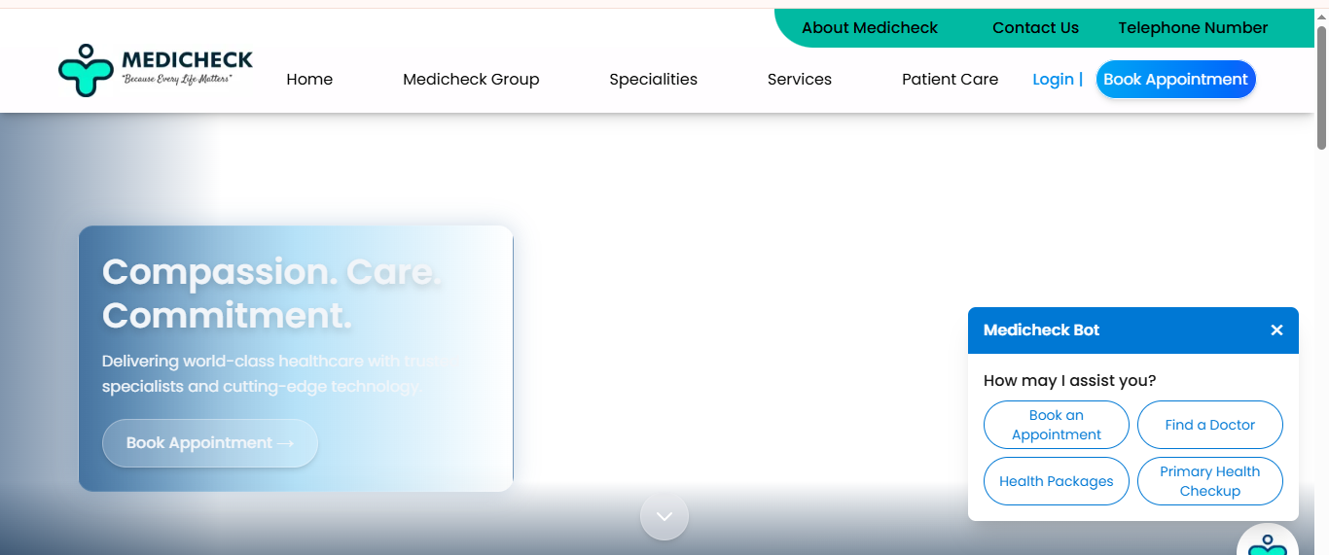
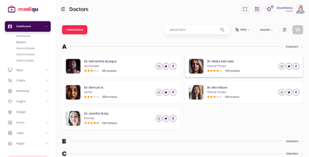 | 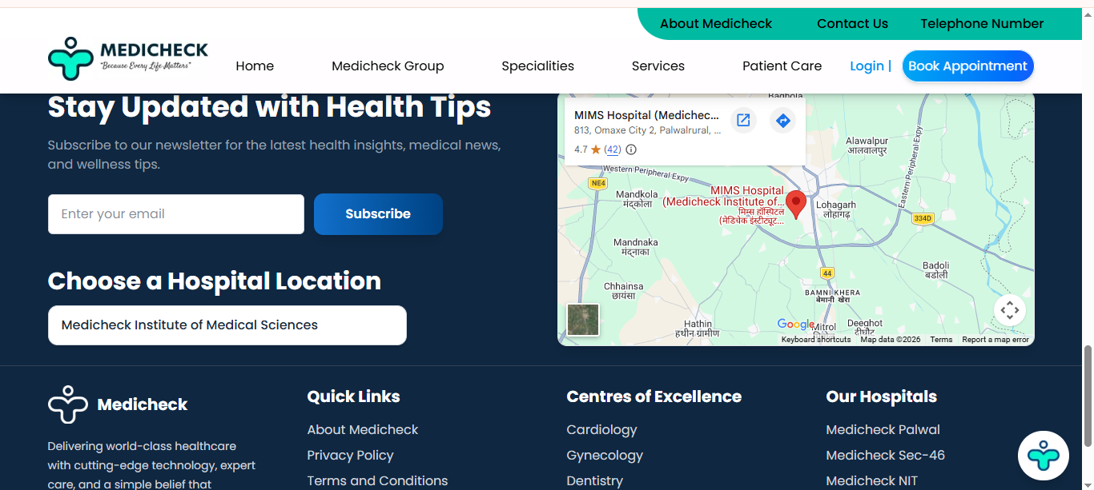

7.5 User Dashboard Screen
Layout: Three summary stat cards at the top (total symptom checks, upcoming appointments, last urgency result). Below: two sections side by side on desktop – 'Symptom History' (list of past checks with date and urgency badge) and 'Upcoming Appointments' (list with hospital name, date, time, and a Cancel button).

7.6 Admin Dashboard Screen
Layout: Left sidebar with navigation links (Dashboard, Hospitals, Users, Appointments, Reports). Main content area on the right.
Hospital management: A data table showing all hospitals with columns: Name, Specializations, Status, and Actions (Edit / Delete buttons). An 'Add New Hospital' button above the table opens a modal form.
Users table: Shows registered users with email, phone, registration date, and a Deactivate button.
Appointments table: Shows all bookings with patient name, hospital, date, time, and status.

REFERENCES

Books
Sommerville, I. (2016). Software Engineering (10th ed.). Pearson Education. [Used for software design documentation standards and architectural design principles.]
Pressman, R. S., and Maxim, B. R. (2015). Software Engineering: A Practitioner's Approach (8th ed.). McGraw-Hill Education. [Used for test case design methodology and software design concepts.]
Fowler, M. (2002). Patterns of Enterprise Application Architecture. Addison-Wesley. [Used for RESTful API design and MVC architectural patterns.]

Academic Papers and Standards
IEEE. (1998). IEEE Recommended Practice for Software Requirements Specifications (IEEE Std 830-1998). Institute of Electrical and Electronics Engineers. https://ieeexplore.ieee.org/document/720574
Rajpurkar, P., Chen, E., Banerjee, O., and Topol, E. J. (2022). AI in health and medicine. Nature Medicine, 28, 31–38. https://doi.org/10.1038/s41591-021-01614-0
Semigran, H. L., Linder, J. A., Gidengil, C., and Mehrotra, A. (2015). Evaluation of symptom checkers for self-diagnosis and triage. BMJ, 351, h3480. https://doi.org/10.1136/bmj.h3480

Official Technical Documentation
Meta Platforms, Inc. (2024). React Documentation. https://react.dev
OpenJS Foundation. (2024). Node.js Documentation. https://nodejs.org/en/docs
MongoDB, Inc. (2024). MongoDB Documentation. https://www.mongodb.com/docs
Google LLC. (2024). Google Maps Platform Documentation. https://developers.google.com/maps/documentation/javascript
Google LLC. (2024). Gemini API Documentation. https://ai.google.dev/docs
Twilio Inc. (2024). Twilio SMS API Documentation. https://www.twilio.com/docs/sms
Redis Ltd. (2024). Redis Documentation. https://redis.io/docs
Auth0 by Okta. (2024). Introduction to JSON Web Tokens. https://jwt.io/introduction
JGraph Ltd. (2024). draw.io – Free Online Diagram Software. https://app.diagrams.net

